Raspberry PI 128x128 1.44” LCD HAT

May 26, 2018

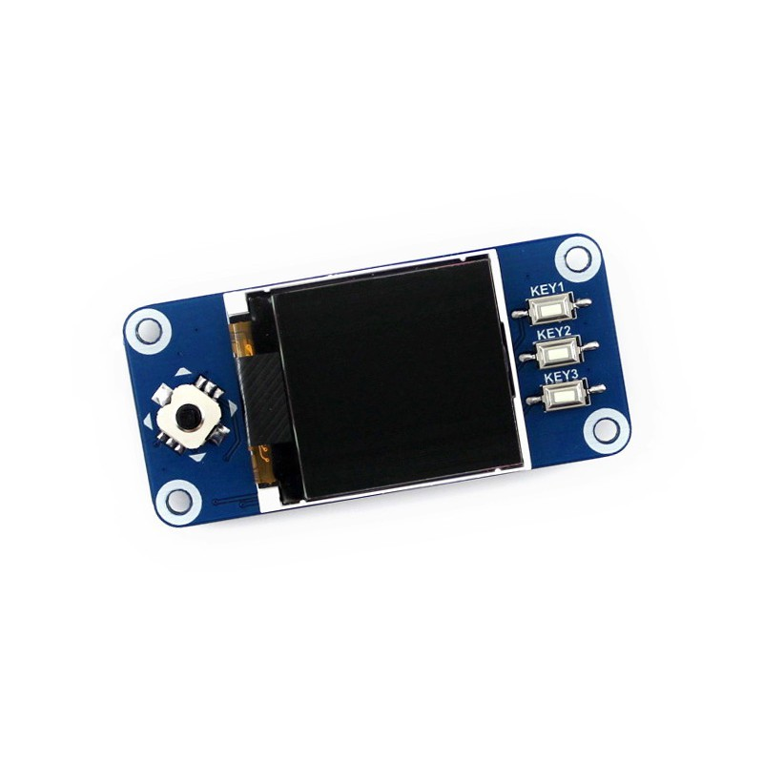

Found one of these on eBay for about $15.00 - it has a TFT LCD color display, 4 buttons, and a 4 way joystick. It fits nicely on a PI Zero (W), but can be used on the PI 2 and 3.

More Information can be found here:

<https://www.waveshare.com/1.44inch-lcd-hat.htm>

<https://wavesharejfs.blogspot.com/2018/03/raspberry-pi-driv-144inch-lcd-hat-with.html>

<https://www.raspberrypi.org/forums/viewtopic.php?t=207627>

Here is a library for it:

<http://www.airspayce.com/mikem/bcm2835/index.html>

<https://www.raspberrypi.org/forums/viewtopic.php?t=15892>

Here is the PINs used:

| **SYMBOL** | **Raspberry Pi PIN (BCM)** | **DESCRIPTION** |
| --- | --- | --- |
| KEY1 | P21 | Button 1/GPIO |
| KEY2 | P20 | Button 2/GPIO |
| KEY3 | P16 | Button 3/GPIO |
| Joystick Up | P6 | Joystick Up |
| Joystick Down | P19 | Joystick Down |
| Joystick Left | P5 | Joystick Left |
| Joystick Right | P26 | Joystick Right |
| Joystick Press | P13 | Joystick Press |
| SCLK | P11/SCLK | SPI clock input |
| MOSI | P10/MOSI | SPI data input |
| DC | P25 | Data/Command selection (high for data, low for command) |
| CS | P8/CE0 | Chip selection, low active |
| RST | P27 | Reset, low active |
| BL | P24 | Backlight |

Here is the official Wiki for it (Including official demo code and manual.)

<https://www.waveshare.com/wiki/1.44inch_LCD_HAT>

(My PI is 192.168.0.21 or TFTDisplay.local)

Working code tests (From the Waveshare Wiki code):

In screen/RaspberryPi directory

(wiringpi not working at all)

bcm2835 works, remember the code needs to run as sudo

(ctrl-c to exit)

To make a project, copy a working project to new directory,

Edit files in obj directory (main.c) other files as needed.

To compile run the Makefile

Project will compile to tftlcd_1in44 and be an executable.

Rename as needed.

Python code:

In the lcd_demo directory.

Image.py works

Imagebycat.py works

Don’t need sudo, but only appears to partially work. And colors seem wrong.

More:

Using FBI to view images:

Install fbi (sudo apt-get install fbi)

Then:

sudo fbi -T 2 -d /dev/fb1 -noverbose image.jpg

For a slide show

sudo fbi -T 2 -t 5 -d /dev/fb1 -noverbose *.jpg

-t 5 is 5 seconds between pictures, you can also add -a to auto scale pictures.

Mplayer does not appear to work.